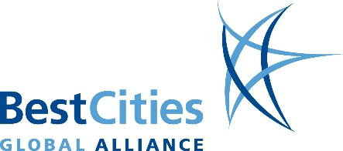
Event Marketing Plan Checklist

- Previous Event History

  - Post event research / surveys / report

  - Promotional strategy and results

  - Previous event pricing and packaging

  - Previous event delegate profile

- Audience Analysis

  - Member profile

  - Geographic source of attendees

  - Reason for attending conference / perceived benefits

  - Survey potential audience

- Competitive Analysis

  - Competitive dates, content & pricing, attendee profile

- Market Environment

  - Economic, political, regulatory environment, safety, travel cost

  - Status of profession/industry

- Value Proposition

  - Key message: Why Attend?

  - Benefits & relevance to potential attendees

  - Benefits to specialist groups

  - Consistent messaging

- Promotional Strategy

  - Set goals

  - Set budget

  - Identify opportunities & set tactics

  - Monitor strategy

  - Event pricing and packaging
- Database Mailing Lists

  - Members

  - Non members

  - Via sponsors, & exhibitors

  - Strategic partners & alliances

  - Segment by special interest

- Timeline

  - Schedule programme announcements/ deadlines

  - Identify promotional opportunities [events, newsletters]

- Promotional Tools

  - Website

  - Social media

  - Smart phone apps

  - Print material

  - Media

  - Email templates, web banners

- Website Development

  - Search engine optimisation

  - Integrate with social media

  - Constantly promote and update

  - Web links

  - Track and monitor visits

- Media

  - Establish media list

  - PR agency

  - Media releases

  - Media conference

  - Advertising, advertorial, editorial

  - Target trade magazines, newsletter & journals

  - Consider translation for key target markets

€ | Pre Conference Events
 | € | Bid win announcements/
 |  | handover
 | € Promote at key regional
 |  | conferences and events
 | € Engage Convention Bureau for
 |  | promotional booth and materials
€ | Extend Promotional Force
 | € | Sponsors and exhibitors
 | € | Regional branches/chapters
 | € | Ambassadors, committee
 |  | members
 | € | Attendees

- International event calendars

- Convention bureau delegate promotion tools

€ | Electronic Direct Marketing
 | € | Customise messaging to
 |  | specialist groups
 | € Language, cultural and regional
 |  | considerations
€ | Pre Engage Audience
 | € | Social media applications
 | € | Programme content
 |  | development
 | € | Event planning surveys
 | € | Abstracts & posters
 | € Destination promotion / Pre and
 |  | post touring/ trip planner

